Shuo Wang (001533020)

**Program Structures & Algorithms**

**Fall 2021**

**Assignment No. 2**

* **Task (List down the tasks performed in the Assignment)**
* **Relationship Conclusion: O(n2)**
* **Evidence to support the conclusion:**

1. **Output (Snapshot of Code output in the terminal)**

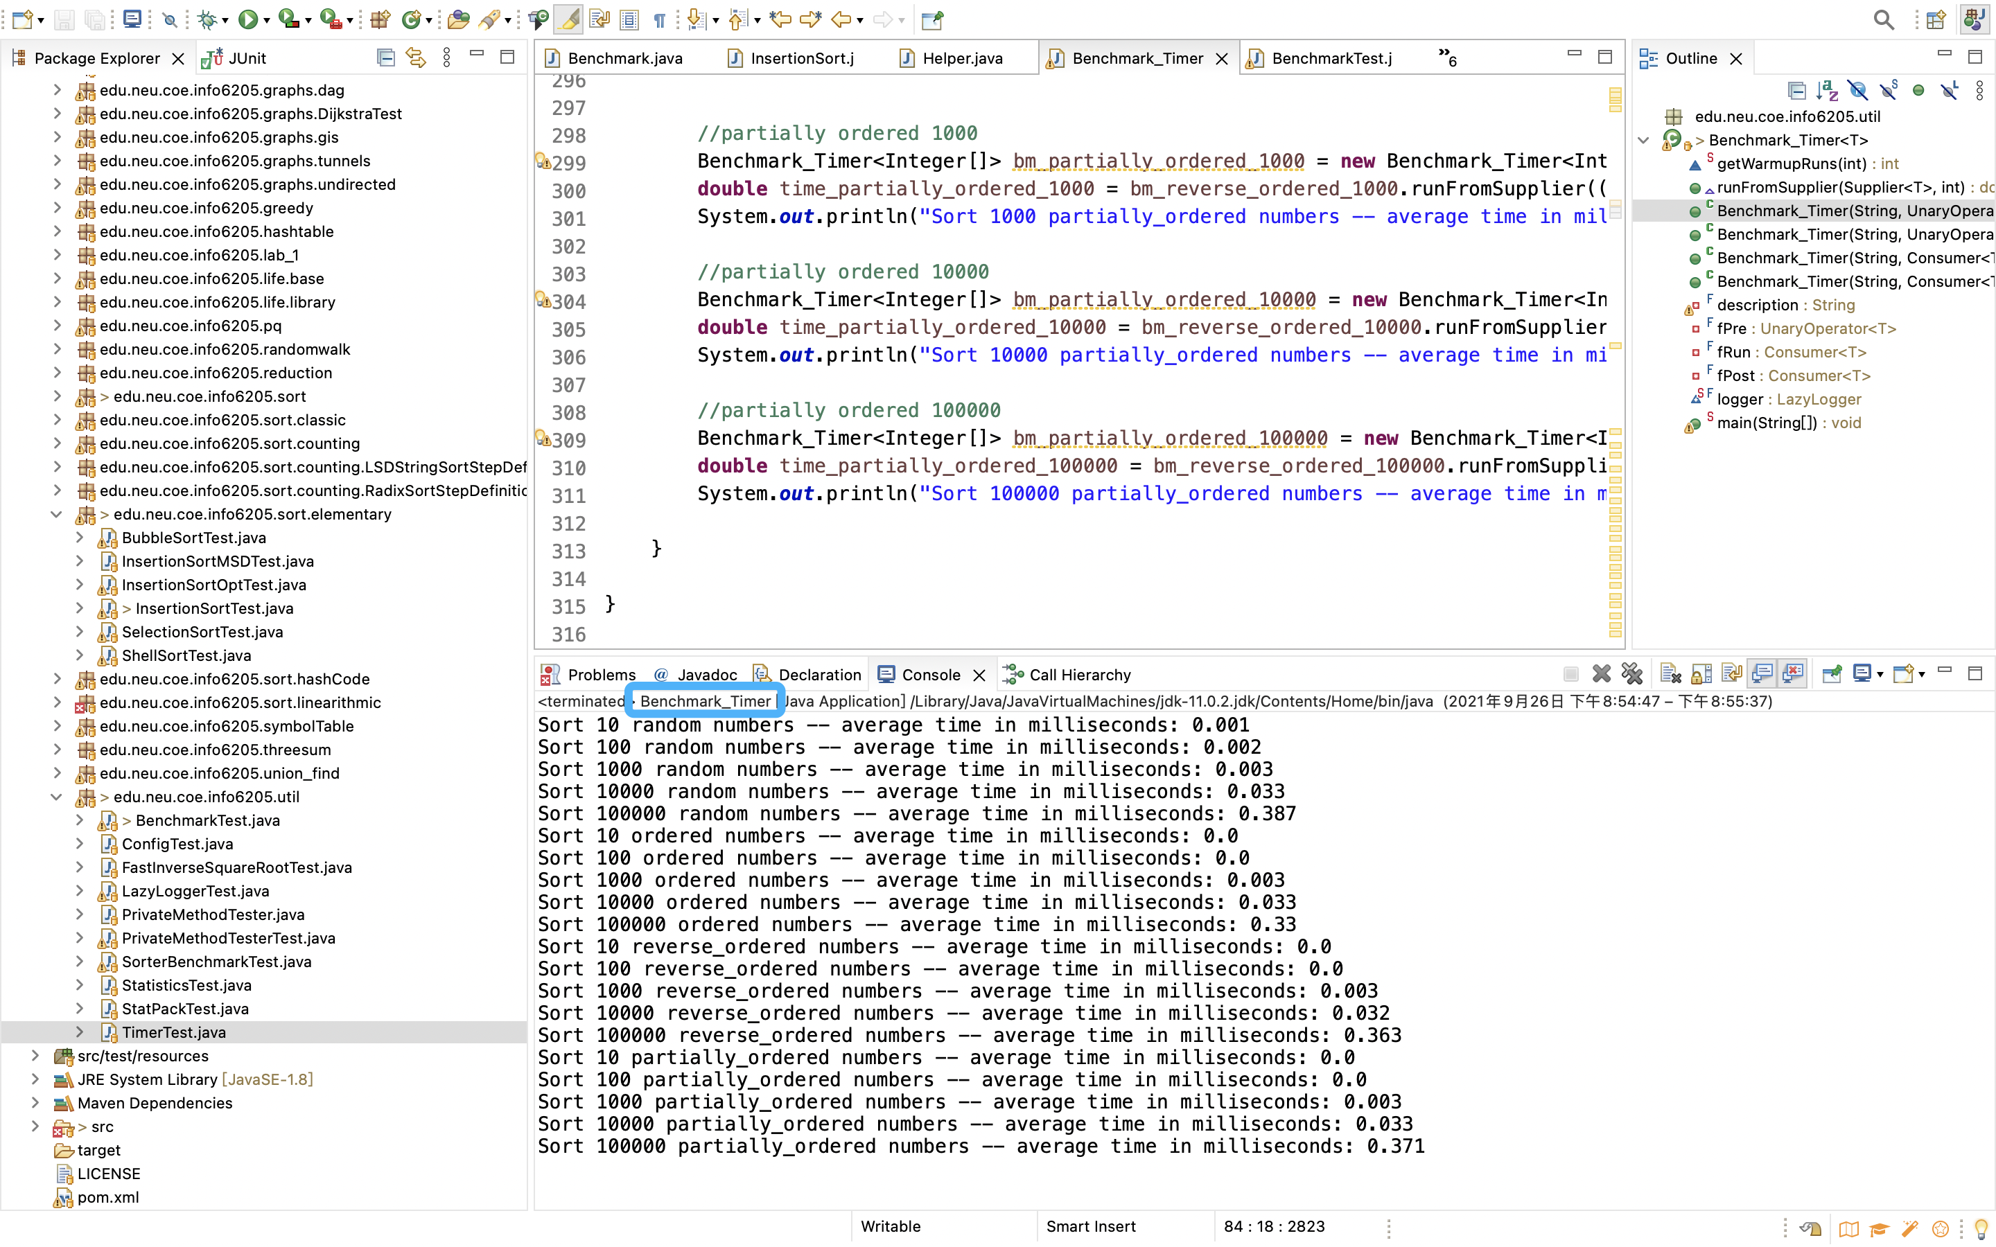

1. **Graphical Representation(Observations from experiments should be tabulated and analyzed by plotting graphs(usually in excel) to arrive on the relationship conclusion)**

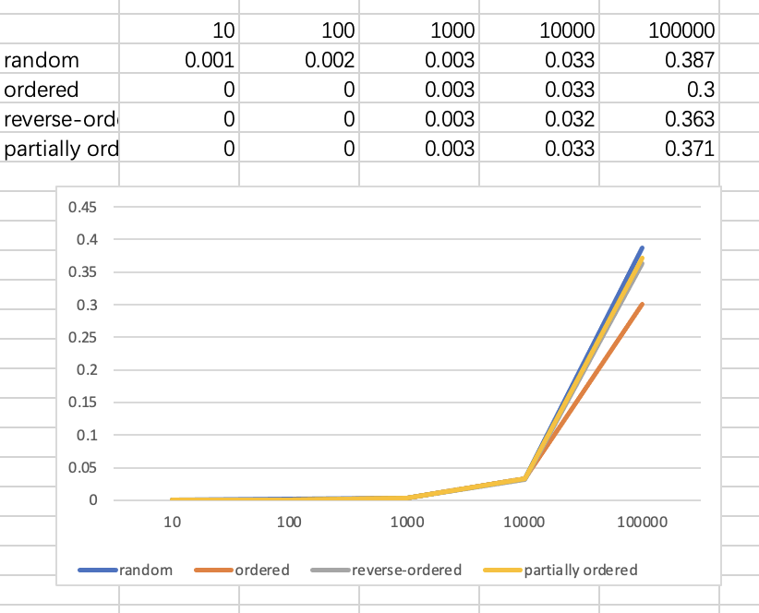

* **Unit tests result:(Snapshot of successful unit test run)**

